Title: Garamond 12 bold
Authors: Name Surname , Garamond 12

Abstract: Garamond 12 bold
  - The manuscript should be prepared on A4 paper with the following margins (cm): 2,4 upper; 1,8 lower; 2,1 left & right; 1,27 header & footer. The font to be used is Garamond 12 with single line spacing. The abstract should be of approximately 200 words, and authorship, contact addresses and any acknowledgements should be submitted on a separate cover letter as the refereeing process is strictly anonymous. The article length should be between 4000 and 8000 words including references.
Keywords: Garamond 12 bold

Keyword 1; Keyword 2; Keyword 3; Keyword 4; Keyword 5

Headings (Garamond 12 bold)
  - First-level headings are bold, font size 12p; second-level subheadings are italic bold, font size 12p. No numbering is required. Further levels of subheadings should be avoided.
  - Quotations are in brackets. In case of more than about 60 words, they should be set out from the text with space above and below.
Second-level subheadings (Garamond 12 italic bold)
  - Second-level subheadings are italic bold, font size 12p. No numbering is required. Further levels of subheadings should be avoided.
Illustrations
  - Any maps, diagrams and figures should be submitted in the form of completed artwork suitable for reproduction.
  - Figures and images should be put separately from the text and captioned in the text.
  - Black and white figures should be supplied on separate sheets at the end of the manuscript. Lines should be clean and clear; tints and complex shading should be avoided. Any labels and keys must be legible when reproduced. Figures supplied to at least 800dpi halftones to 300dpi at actual size.
  - Where artwork is supplied, please remember that illustrations cannot be reproduced at more than the size of the text area of the journal page. All illustrations should be drawn for the same reduction, ideally 3:2. Lettering should be of draughtsman standard; please bear the reduction factor in mind in both lettering and line weight.

  - Good quality black and white photographs will be considered for inclusion where they add substantially to the argument, up to a maximum of three per article. These can be supplied electronically to at least 300dpi.
  - Colour figures can be provided for use in the online version. However, contributors must remember that these will appear in the printed version in black and white. Any colours used should therefore be distinguishable from each other in the greyscale format, especially in pie charts and bar charts.
  - It is the contributor's responsibility to clear any necessary copyright permissions, to pay any reproduction fees charged by the copyright owner, and to provide a list of captions and (where relevant) credit lines.
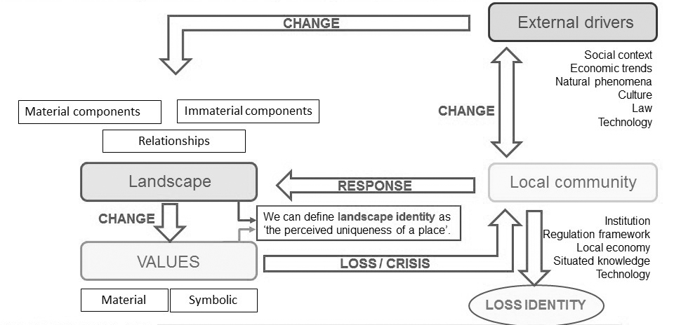
  - A list of captions to the illustrations should be supplied separately from the text, and the position of the illustrations should be clearly indicated in the text.
Figure 1 - Caption

Tables
Tables should be typed on separate sheets from the text, and their position in the text indicated.

FRAGILE | RESILIENT(ANTI-FRAGILE)
Isolated - detached | Connected
Uniform - serial | Differentiated
Poor | Rich
Scarce | Redundant
Unable | Capable
Table 1 – Resiliency features of a cultural landscape
References
Bibliographic citations must be indicated in the text by surnames of the author and the year of publication in parentheses, e.g. Hall (1992). In the case of multiple citations of the same author and year, the year of publication must be followed by a letter (a, b, c...).
All bibliographical references must be listed at the end of the text (bibliography must include only the works cited), by using the items of the original publication and by translating the titles of papers and volumes into English, following the "Harvard" format. Here are some examples:
Badie B. (1996), La Fine dei Territori. Saggio sul Disordine Internazionale e sull’Utilità Sociale del Rispetto, Trieste, Astesis [or. ed. La Fin des Territoires. Essai sur le Désordre International et l’Utilité Social du Respect, 1996].
Biscaretti di Ruffia P. (1992), Territorio dello Stato [The Territory of the State], in Enciclopedia del Diritto [Law Enciclopedy]. 1958-2012. Tomo XLIV, Milano, Giuffré, pp. 333-355.
- In the case of a book
Miller W. (2012) Introducing Geodesign: The Concept, Redlands, ESRI Press.
Campagna M. (2016), Social media geographic information: Why social is special when it goes spatial?, in Capineri C., Haklay M., Huang H, Antoniou V., Kettunen J., Ostermann F., Purves R. (eds.) European Handbook of Crowdsourced Geographic Information, London, Ubiquity Press, pp. 45–54.
- In the case of a journal article
Campagna M., Moura A.C.M., Borges J., Cocco C. (2016), Future scenarios for the Pampulha region: A geodesign workshop. Journal of Digital Landscape Architecture, 1, pp. 292–301.
- In the case of a conference proceedings
Rivero R., Smith A., Ballal H., Steinitz C. (2015), Promoting collaborative geodesign in a multidisciplinary and multiscale environment: Coastal Georgia 2050, USA, in Buhmann E., Ervin S., Pietsch M. (eds), Proceedings Of Digital Landscape Architecture 2015, Berlin/Offenbach, Wichmann, pp. 42–58.
- In the case of a report
Vandenbroucke D. (2007) Spatial data infrastructures in Europe: State of play 2007, Summary report of a study commissioned by the EC (EUROSTAT) in the framework of the INSPIRE initiative (Under Framework Contract REGIO/G4-2002-02-Lot 2), [http://inspire.ec.europa.eu/reports/stateofplay2007 /INSPIRE-SoP-2007v4.pdf, Last visited 15.06.2018]
Copyright
Authors must obtain permission to reproduce copyright maps and diagrams. Full information of work cited - author, date, publisher and page references - should be given for all maps, diagrams and figures. Single passages of quoted prose should not normally exceed 250 words, or scattered passages more than 400 words, from any work
Authors will be required to assign copyright in their paper to Plurimondi. Copyright assignment is a condition of publication and papers will not be passed to the publisher for production unless copyright has been assigned. To assist authors an appropriate copyright assignment form will be supplied.

*Authors Affiliation, Country

